Supplementary Information
Table S1. Recording schedule. Recording schedule for deployments from both sites. Deployments with a 25 kHz crossover between the low and high frequency hydrophones have been bolded. Lines in-between rows represent different sites, including Manawai subsites 1-2.
Deployment | Sampling Frequency (kHz) | Duty Cycle  (minutes on/ total minutes) | Latitude, Longitude  (decimal degrees) | Instrument Depth  (nearest 10 meters) | Start Date | End Date
Hawaiʻi05 | 200 | 5/5 | 19.578, -156.014 | 550 | 2009-02-10 | 2009-04-01
Hawaiʻi06 | 200 | 5/15 | 19.583, -156.016 | 750 | 2009-04-23 | 2009-08-18
Hawaiʻi07 | 200 | none | 19.582, -156.015 | 720 | 2009-10-25 | 2009-12-15
Hawaiʻi08 | 200 | 5/12 | 19.581, -156.015 | 750 | 2009-12-20 | 2010-03-05
Hawaiʻi09 | 200 | none | 19.581, -156.016 | 750 | 2010-05-01 | 2010-06-16
Hawaiʻi10 | 200 | 5/8 | 19.582, -156.015 | 720 | 2010-09-30 | 2011-03-12
Hawaiʻi11 | 200 | 5/8 | 19.582, -156.015 | 720 | 2011-05-12 | 2011-10-22
Hawaiʻi16 | 200 | 5/15 | 19.583, -156.015 | 720 | 2013-10-23 | 2014-04-03
Hawaiʻi17 | 200 | none | 19.583, -156.016 | 720 | 2014-03-25 | 2014-07-14
Hawaiʻi18 | 320 | none | 19.583, -156.016 | 720 | 2014-07-28 | 2014-10-12
Hawaiʻi19 | 320 | none | 19.583, -156.016 | 720 | 2014-12-06 | 2015-03-06
Hawaiʻi20 | 320 | none | 19.583, -156.016 | 720 | 2015-04-25 | 2015-08-18
Hawaiʻi22 | 200 | none | 19.583, -156.016 | 720 | 2015-11-07 | 2016-03-19
Hawaiʻi23 | 200 | none | 19.583, -156.016 | 720 | 2016-07-04 | 2016-09-14
Hawaiʻi26 | 200 | none | 19.582, -156.015 | 740 | 2017-07-12 | 2017-10-25
Hawaiʻi27 | 200 | none | 19.583, -156.016 | 750 | 2017-10-26 | 2018-04-25
Hawaiʻi28 | 200 | none | 19.583, -156.016 | 730 | 2018-04-29 | 2018-11-19
Hawaiʻi29 | 200 | none | 19.583, -156.016 | 740 | 2018-11-23 | 2019-03-31
Hawaiʻi30 | 200 | none | 19.583, -156.015 | 700 | 2019-04-04 | 2019-09-29
Manawai01 | 200 | 5/20 | 27.725, -175.638 | 770 | 2009-10-20 | 2010-05-24
Manawai02 | 200 | none | 27.727, -175.632 | 750 | 2010-06-01 | 2010-09-17
Manawai04 | 200 | none | 27.725, -175.638 | 770 | 2011-04-12 | 2011-07-29
Manawai05 | 200 | 5/8 | 27.725, -175.638 | 770 | 2011-08-15 | 2012-01-07
Manawai08 | 200 | 5/20 | 27.742, -175.559 | 970 | 2014-09-12 | 2015-07-16
Manawai09 | 200 | 5/30 | 27.742, -175.560 | 960 | 2015-10-15 | 2016-08-14
Manawai10 | 200 | 5/30 | 27.741, -175.560 | 960 | 2016-08-20 | 2017-03-14

Supplementary Notes
- Correlation analysis
Correlation analyses were undertaken to supplement this manuscript. Monthly values of each variable (satellite-derived chlorophyll-a from NASA MODIS, sea surface salinity, temperature, and height from HYCOM) were calculated across the Hawaiian archipelago. These values were then correlated with climate indices (ENSO, PDO, NPGO) across the years 2008-2019 using corrcoef() in MATLAB (Mathworks, 2021).
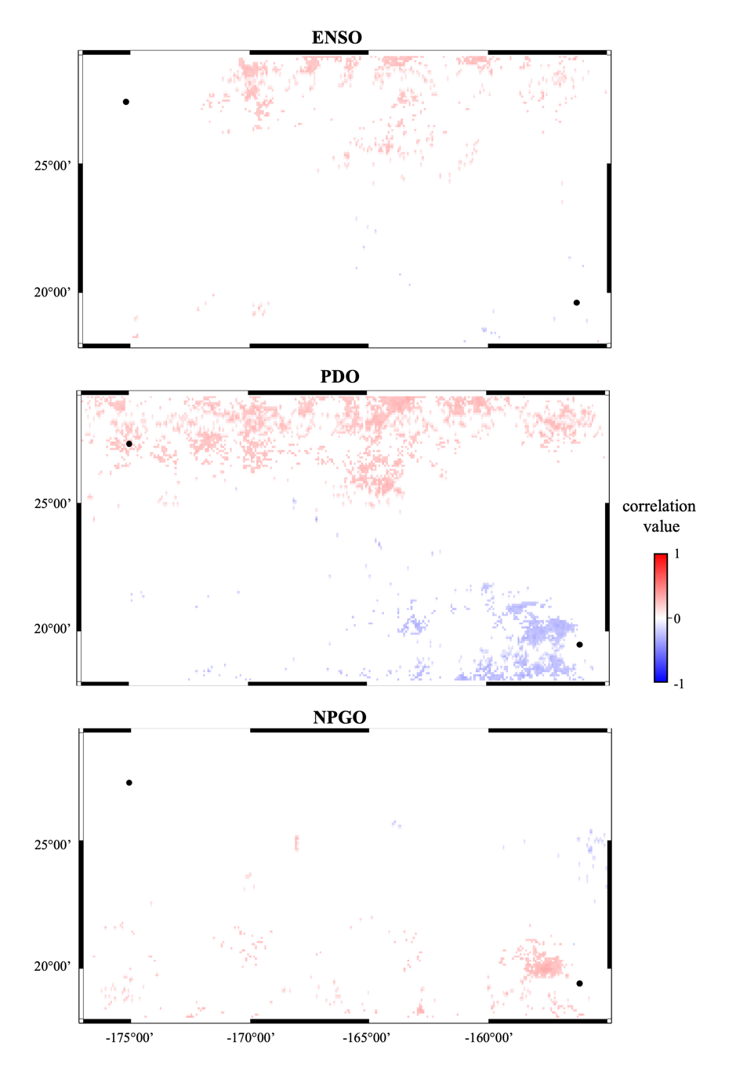

Figure S1. Correlation analysis for chlorophyll-a. Map showing correlation between satellite-derived surface chlorophyll-a concentration and (a) ENSO, (b) PDO, and (c) NPGO state across the Hawaiian Islands. Black markers show the approximate location of Hawaiʻi and Manawai. Only correlations with p<0.05 are displayed.

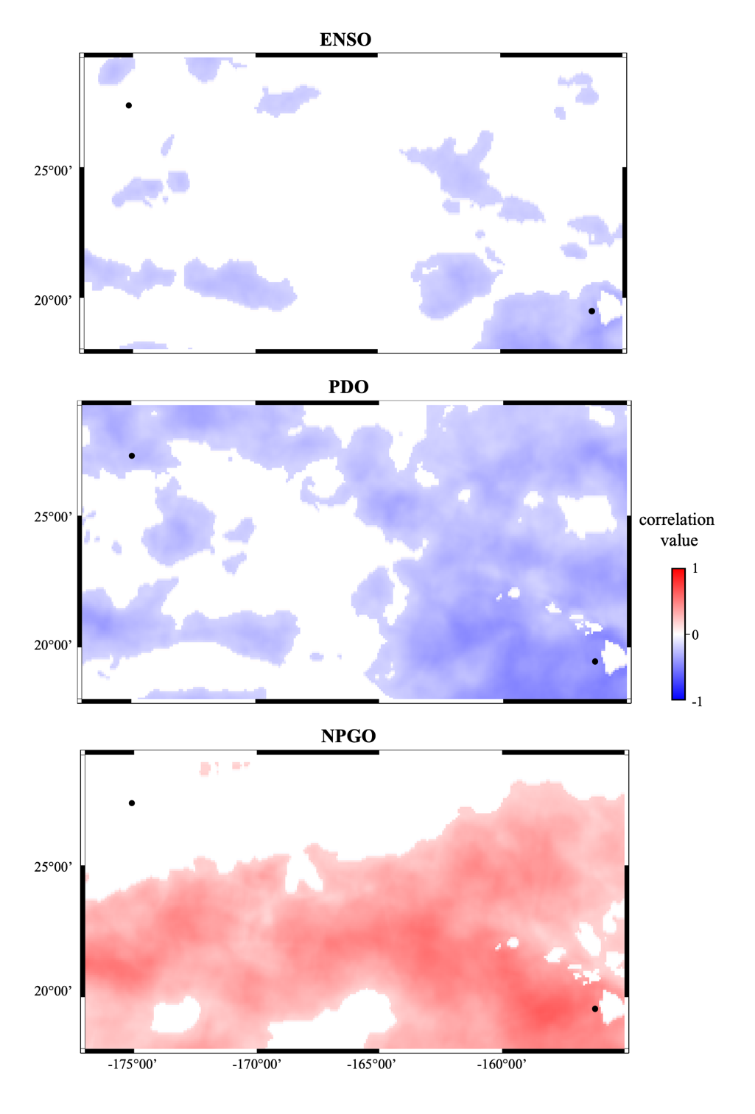
Figure S2. Correlation analysis for sea surface salinity. Map showing correlation between modelled sea surface salinity and (a) ENSO, (b) PDO, and (c) NPGO state across the Hawaiian Islands. Black markers show the approximate location of Hawaiʻi and Manawai. Only correlations with p<0.05 are displayed.

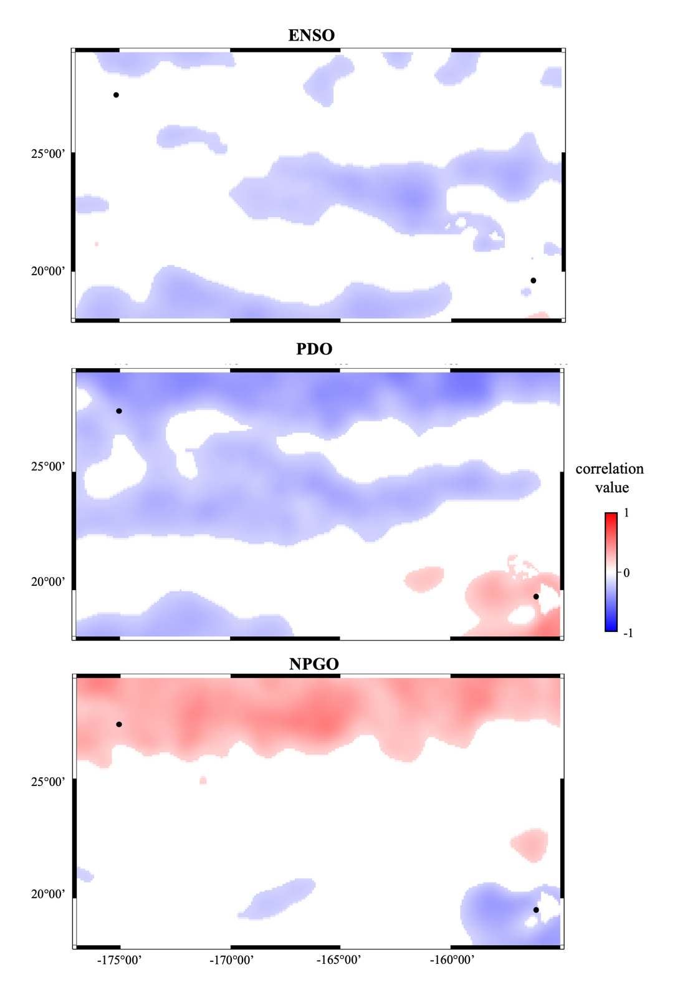
Figure S3. Correlation analysis for sea surface height. Map showing correlation between modelled sea surface height and (a) ENSO, (b) PDO, and (c) NPGO state across the Hawaiian Islands. Black markers show the approximate location of Hawaiʻi and Manawai. Only correlations with p<0.05 are displayed.

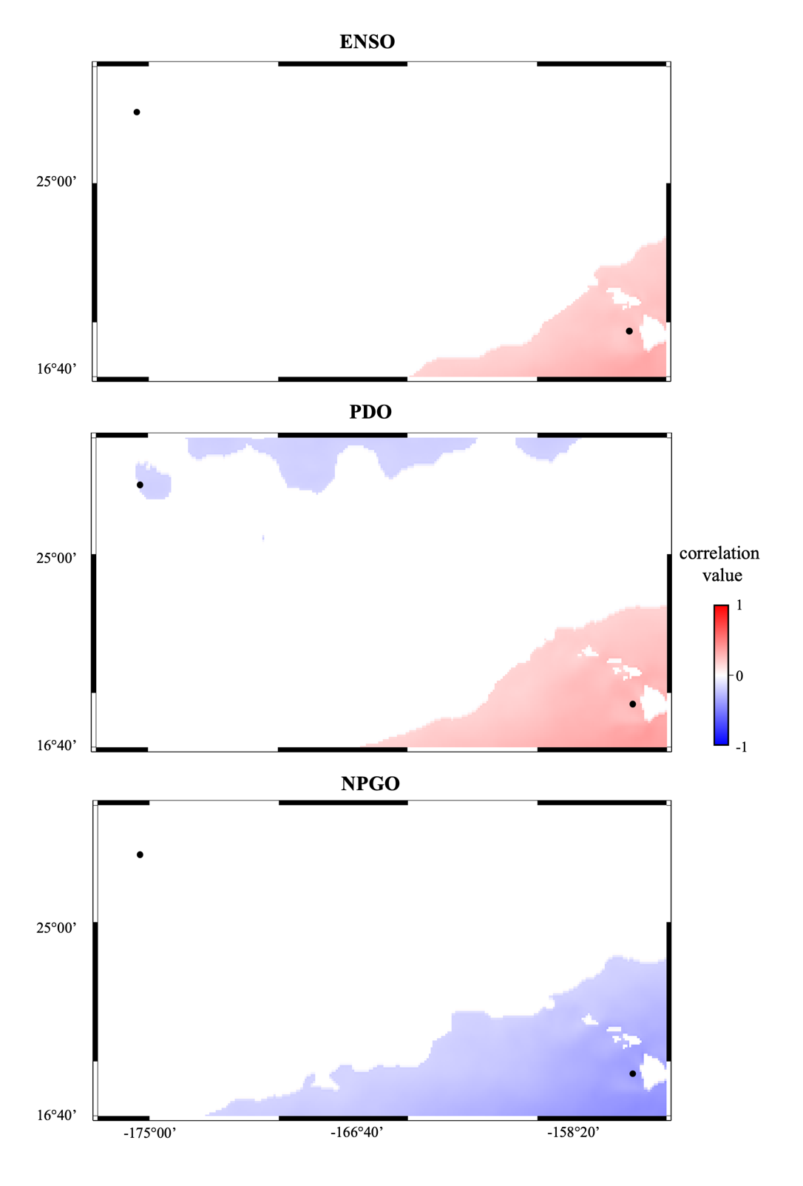
Figure S4. Correlation analysis for sea surface temperature. Map showing correlation between modelled sea surface temperature and (a) ENSO, (b) PDO, and (c) NPGO state across the Hawaiian Islands. Black markers show the approximate location of Hawaiʻi and Manawai. Only correlations with p<0.05 are displayed.

Supplementary References
Mathworks. (2021). MATLAB (9.11 (R2021b)). Natick, Massachusetts: The MathWorks Inc.

