Supplementary Materials for
Deriving probabilistic age estimates using common photo-identification catalog information: An application to endangered Hawaiian false killer whales (Pseudorca crassidens)
Michaela A. Kratofil^{1*}, Sabre D. Mahaffy¹, Karen K. Martien², Frederick I. Archer², Kristi L. West^{3,4}, Susan J. Chivers², Robin W. Baird¹
¹Cascadia Research Collective, Olympia, Washington, USA
²Southwest Fisheries Science Center, National Marine Fisheries Service, La Jolla, California, USA
³Hawai‘i Institute of Marine Biology, Kaneohe, Hawai‘i , USA
⁴Human Nutrition Food and Animal Sciences, College of Tropical Agriculture and Human Resources, University of Hawai‘i at Mānoa, Honolulu, Hawai‘i, USA
*Correspondence: mkratofil@cascadiaresearch.org

Growth layer group (GLG) count methods for aging teeth of stranded false killer whales
General: Teeth were collected from five dead stranded false killer whales. Four of the five individuals had been previously photographed and were part of Cascadia Research Collective’s long-term photo-identification catalog; these individuals are included in the total 81 sampled individuals reported in our study. The fifth individual (HIPc700) had not been documented prior to stranding, but was added to the catalog post-stranding and confirmed to belong to the main Hawaiian Islands insular population via match of mitochondrial haplotype (see Martien et al., 2014).
Age was estimated by counting dentinal growth layer groups (GLGs) in acid-etched teeth using techniques commonly applied to aging marine mammals with large teeth (Perrin and Myrick 1980; Hohn 2018; Rust et al. 2019). Two teeth from each individual were prepared for aging using similar techniques. All teeth were first cut along the mid-longitudinal plane to reveal the center dentine layers using water-cooled diamond blades mounted on a Gryphon AquaSaw Diamond Band Frag Saw (Bulk Reef Supply, Golden Valley, Minnesota, USA; also referred to as a ‘coral saw’) or a Buehler IsoMet Low Speed Saw (Lake Bluff, Illinois, USA; hereafter, ‘IsoMet saw’), which is widely used to prepare marine mammal teeth for aging.
Coral saw preparation & readings: The biggest and least worn tooth from each specimen was prepared at the University of Hawaiʻi using the coral saw. Each tooth was cut slightly off the mid-longitudinal center line of the tooth to provide sufficient material to polish the tooth’s surface prior to etching. Each tooth was wet-sanded using 400, 600, 1000, 1500 and 2000 grit water-coated sandpaper until the centerline of the tooth was revealed. The polished tooth was then etched using dilute formic acid (15%) and acetone baths, and then rinsed with water for three minutes and dried. This process was repeated until the dentinal GLGs were visible, and a #1 soft-graphite pencil rubbed along the surface of the tooth enhanced the GLGs well enough to count. Photographs of the prepared teeth were provided to a single reader, who aged each tooth once. Due to difficulty visualizing the central growth layers, the resulting estimates for three of the five teeth are considered minimums (Table S1).
IsoMet saw preparation & readings: The straightest and least worn teeth from each specimen were selected for preparation with the IsoMet saw at the NOAA Southwest Fisheries Science Center. Each tooth was first cut along the mid-longitudinal plane of the tooth using an IsoMet saw and then the interior surface was polished and serially acid-etched to reveal the dentinal GLGs. The preparation methods are similar to those described above for coral saw preparations, and those used for sperm whale teeth (Evans and Robertson 2001) and California sea lions (Rust et al. 2019) with necessary adjustments to acid etching time. One reader independently aged each specimen three times without knowledge of the data available for each specimen or previous GLG counts. Because there is inherent uncertainty in GLG age estimates, readers typically record a best, high, and low estimate during each read. The final age for a specimen is the mean of all readings rounded to the nearest whole year. We characterize the GLG aging uncertainty here with the coefficient of variation (CV) of the mean best age together with the youngest and oldest estimates of a readers’ low and high estimates from all reads (Table S1).
Comparing estimates: We compared GLG estimates to the photo-identification catalog-derived estimates in Table S1 below. The comparability of the GLG estimates to our catalog-derived estimates supported high confidence ratings (CR) for all stranded individuals. To demonstrate how the lack of GLG estimates increases uncertainty in catalog-derived estimates for these stranded individuals, we also provided the catalog-derived estimates and confidence rating scores that disregarded the GLG estimates (Table S1).
Table S1. Growth layer group (GLG) counts for stranded false killer whales. Only a single read of GLG counts was done for the coral saw-prepared teeth, and thus only best or minimum age estimates are reported in this column. Sex and male maturity as indicated by dorsal fin morphology (DPM = developing physically mature; PM = physically mature) are provided. Photo-identification catalog-based best, minimum, and maximum age estimates (Age_{best}, Age_{min}, Age_{max}, respectively) and confidence ratings (CR) are also provided to compare to GLG estimates. The photo-identification catalog-based age estimates and CRs disregarding GLG estimates (which influence CR) are also provided.
Catalog ID | Lab ID | Sex | Evidence for male physical maturity at necropsy | Coral saw GLG count (minimum or best) | IsoMet saw GLG count (mean best/CV/low/high) | Photo-ID based Age_{best} (Age_{min}-Age_{max}); CR considering GLGs | Photo-ID based Age_{best} (Age_{min}-Age_{max}); CR disregarding GLGs
HIPc199 | KW2010019 | Female | NA | 18 (minimum) | 25/6.9/22/28 | 24 (20-34); 5 | 24 (20-39); 4
HIPc162 | KW2013018 | Male | PM | 14 (minimum) | 22/4.9/20/25 | 25 (20-35); 5 | 25 (20-40); 4
HIPc198 | KW2015015 | Female | NA | 12 (minimum) | 22/5.2/18/24 | 21 (17-31); 5 | 21 (17-51); 3
HIPc164 | KW2016016 | Male | DPM | 17 (best) | NA | 19 (16-24); 5 | 19 (16-24); 4
HIPc700 | KW2016020 | Female | NA | 13 (best) | 16/7.6/14/20 | 10 (6-20); 5 | 10 (10-65); 1

References:
Evans, K., and K. Robertson, K. 2001. “A note on the preparation of sperm whale (Physeter macrocephalus) teeth for age determination.” Journal of Cetacean Research and Management 3(1):101-107.
Hohn, A.A. 2018. “Age estimation.” In Encyclopedia of Marine Mammals (3rd edition) edited by B. Würsig, J.G.M. Thewissen, and K.M. Kovacs, 10-14. Elsevier Inc., Academic Press, San Diego.
Perrin, W.F., and A.C. Myrick. 1980. Age determination of toothed whales and sirenians. International Whaling Commission, Cambridge
Rust, L., K. Danil, S.R. Melin, and B. Wilkerson. 2019. “Accuracy and precision of age determination using growth layer groups for California sea lions (Zalophus californianus) with known ages.” Marine Mammal Science 35(4):1355-1368. https://doi.org/10.1111/mms.12605

Examples of progression of dorsal fin morphology with physical maturity in males
Figure S1 shows examples of the progression of dorsal fin morphology for male false killer whales (genetically confirmed sex) documented over multiple age classes (see Table 2, Figure 3). The leading-edge hump of the dorsal fin is the primary feature that appears to develop with physical maturity, although we also point out additional growth above the horizontal axis of the body (Figure S1, HIPc114). Some individuals shown in these examples also had photographs showing head morphology from which we could additionally infer the level of physical maturity (see Figure 1 for sexually dimorphic head morphology in false killer whales). We acknowledge that some individual variation in dorsal fin morphology exists in the examples provided. Variation in the expression of sexually dimorphic characteristics is known to occur in a number of species, and can be driven by factors such as genetics, condition/nutrition, and environmental variation (e.g., Bonduriansky 2007; Parker and Garant 2004; Post et al. 1999).
References
Bonduriansky, R. 2007. “The evolution of condition-dependent sexual dimorphism.” The American Naturalist 169(1):9-19. https://doi.org/10.1086/510214
Martien, K.K., S.J. Chivers, R.W. Baird, et al. 2014. “Nuclear and mitochondrial patterns of population structure in North Pacific false killer whales (Pseudorca crassidens).” Journal of Heredity 105(5):611-626. https://doi.org/10.1093/jhered/esu029.
Parker, T.H., and D. Garant. 2004. “Quantitative genetics of sexually dimorphic traits and capture of genetic variance by a sexually-selected condition-dependent ornament in red junglefowl (Gallus gallus).” Journal of Evolutionary Biology 17:1277-1285. https://doi.org/10.1111/j.1420-9101.2004.00769.x
Post, E., R. Langvatn, M.D. Forchammer, and N.C. Stenseth. 1999. “Environmental variation shapes sexual dimorphism in red deer.” Proceedings of the National Academy of Sciences 96:4467-4471. https://doi.org/10.1073/pnas.96.8.4467
Credits for photographs in Figure S1 by catalog ID
HIPc114: 1990, 1998 - Daniel J. McSweeney; 2001, 2008 – Robin W. Baird/Cascadia Research Collective; 2010 – Daniel J. McSweeney/Cascadia Research Collective; 2018 – Jordan K. Lerma/Cascadia Research Collective.
HIPc207: 1986 - Daniel J. McSweeney; 2005 - Mark Deakos, Dan Salden; 2006 – Annie B. Douglas/Cascadia Research Collective; 2008 – Tori Cullins/Wild Dolphin Foundation; 2010 – Elisa A. Weiss/Cascadia Research Collective.
HIPc202: 2002 – Pacific Whale Foundation; 2007 – Robin W. Baird/Cascadia Research Collective; 2013 – Chuck Babbitt; 2013 (underwater) – Deron Verbeck; 2018 – Colin J. Cornforth/Cascadia Research Collective; 2022 – Brianna M. Bronson/Cascadia Research Collective.
HIPc176: 2003, 2004 – Cascadia Research Collective; 2010 – Daniel L. Webster/Cascadia Research Collective; 2014, 2017 – Chuck Babbitt; 2020 – Andrea N. McCormick/Captain Zodiac.
HIPc188: 2004 - Cascadia Research Collective; 2008 – Doug Perrine; 2010 – Jessica M. Aschettino/Cascadia Research Collective; 2014 – Chuck Babbitt; 2019 – Alexa Vitek; 2021 – Tori Cullins/Wild Dolphin Foundation.
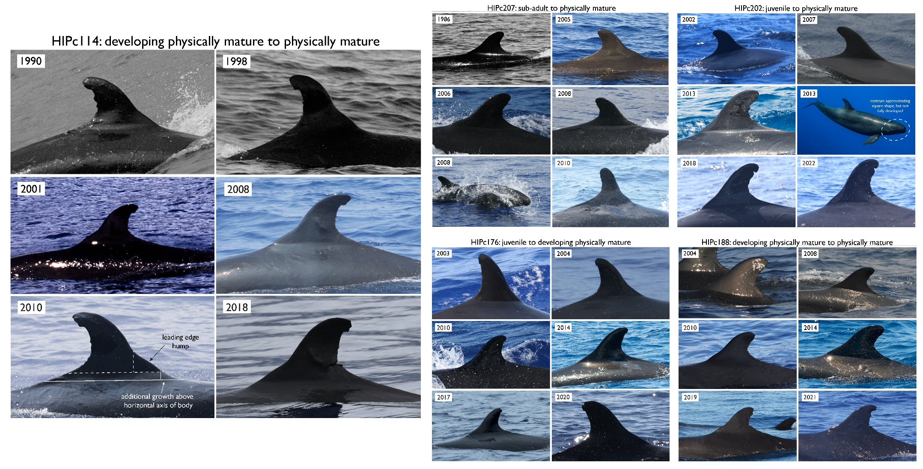
Figure S1. Examples of the progression of dorsal fin morphology in male false killer whales.
Sensitivity analyses
Table S2. Guides for adjusting age estimates based on potential misclassification of age class when first seen. Adjustments were added to age estimates for the scenario in which age class was underestimated, and subtracted from age estimates for the scenario in which age class was overestimated. Adjustment values are derived from the differences between the minimum age value between each age class. For misclassifications of calves and juveniles, an adjustment of 2 years was used instead of 3 years, as young-of-year individuals (i.e., age = 0 years old) would be identifiable through the presence of neonatal folds.
Misclassification of focal individual | Adjustment to age estimates (min/best/max)
Classified as an adult (sexually mature) but truly a sub-adult (vice versa) | +/- 4 years
Classified as a sub-adult but truly a juvenile (vice versa) | +/- 3 years
Classified as a juvenile but truly a calf (vice versa) | +/- 2 years
Classified as developing physically mature adult male but developing/partial dorsal fin morphology expressed earlier/later than we assume | +/- 5 years
Classified as physically mature adult male, but fully developed dorsal fin morphology expressed earlier/later | +/- 10 years

Table S3. Guides for adjusting age estimates based on the lack of genetically determined sex and/or sexually dimorphic features. Adjustment values are derived from the differences between the minimum age value between each relevant age class.
Lack of genetic sex and/or sexually dimorphic features | Individuals with age adjustments | Adjustment to age estimates
No genetic sex; no developing physically mature adult male age class, but physically mature adult male age class remains (i.e., presence of clear sexually dimorphic features available and used) | First seen as developing physically mature adult male | Best: - 5 years  Minimum: - 4 years  Maximum: rule for CR-1
 | Auxiliary years added due to genetic parentage information | All estimates – aux years
No genetic sex; no sexually dimorphic features present | First seen as developing physically mature adult male | Best: - 5 years  Minimum: - 4 years  Maximum: rule for CR-1
 | First seen as physically mature adult male | Best: - 15 years  Minimum: - 9 years  Maximum: rule for CR-1
 | Auxiliary years added due to genetic parentage information | All estimates – aux years

 |  | Median best age (median minimum – median maximum)
Dataset | Scenario | Females | Males
Full | Original | 11 (9-22) | 15 (11-23.5)
 | Overestimated age class | 9 (7-19) | 11 (8-20.5)
 | Underestimated age class | 14 (11-25) | 20 (15-26.5)
CR3+ | Original | 12 (10-20) | 16 (14-24)
 | Overestimated age class | 10 (7-16.5) | 14 (9-21)
 | Underestimated age class | 14 (12-23.5) | 20 (16-27)
CR4+ | Original | 11 (9-14) | 15 (11-23.5)
 | Overestimated age class | 9 (7-12) | 14.5 (12-20)
 | Underestimated age class | 14 (11-16.5) | 20.5 (17-22.5)
Table S4. Summary of median age estimates by sex and across different scenarios explored in the misclassification of age class sensitivity analysis. CR = confidence rating.
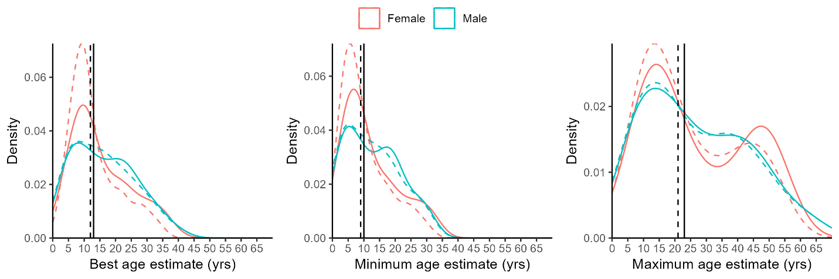
Figure S2. Density distributions of age estimates for the sample population of biopsy sampled Hawaiian false killer whales with auxiliary-based adjustments included (solid lines) and without auxiliary-based adjustments (dashed lines), colored by sex. Vertical lines indicate the median value for each of the two estimate types (original and auxiliary excluded).

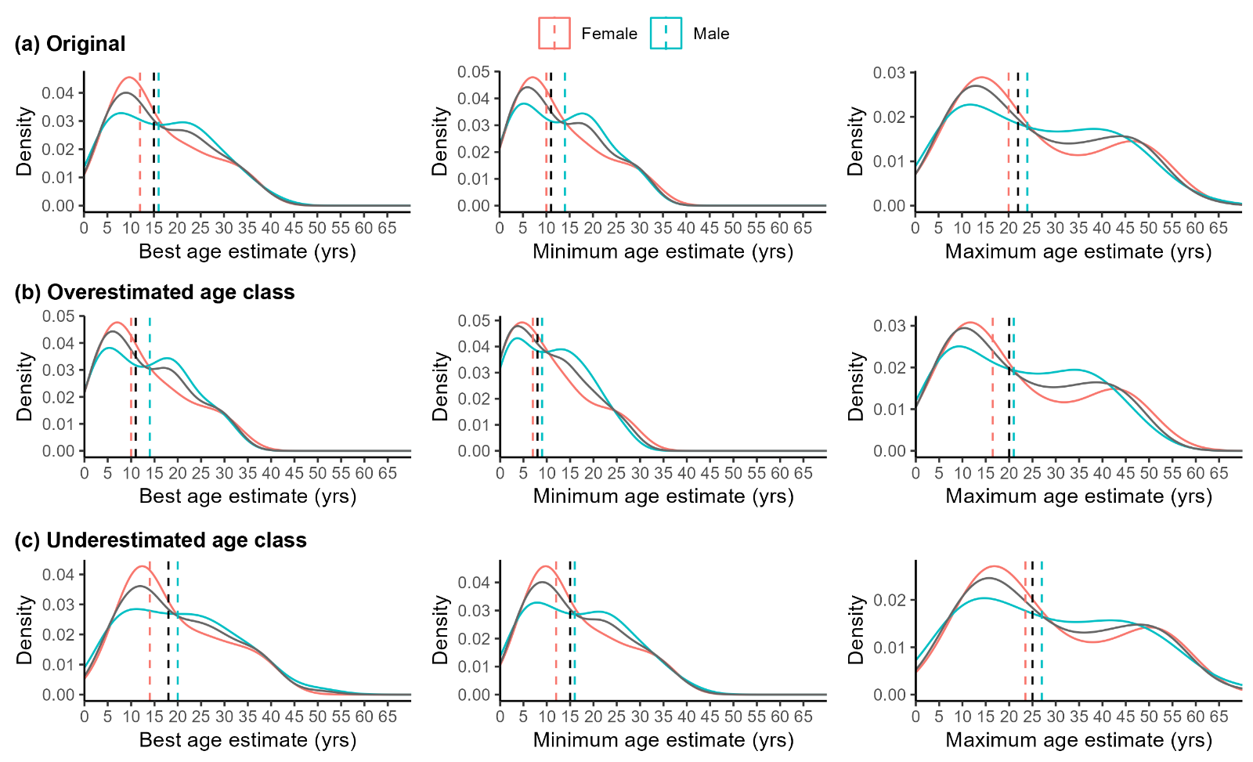
Figure S3. Density distributions of catalog-derived age estimates for all biopsy sampled Hawaiian false killer whales with a confidence rating of three or higher (grey lines) and by sex (colored lines). (a) original age estimates; (b) estimates in the case we overestimated age class when first seen; (c) estimates in the case we underestimated age class when first seen (see Table S2 for details on age adjustments corresponding to (b) and (c)). Vertical black dashed lines represent median values for each category (all, female, male); plots where the black dashed line is not visible indicates that it is equal to the median value of males or females (see Table S4).

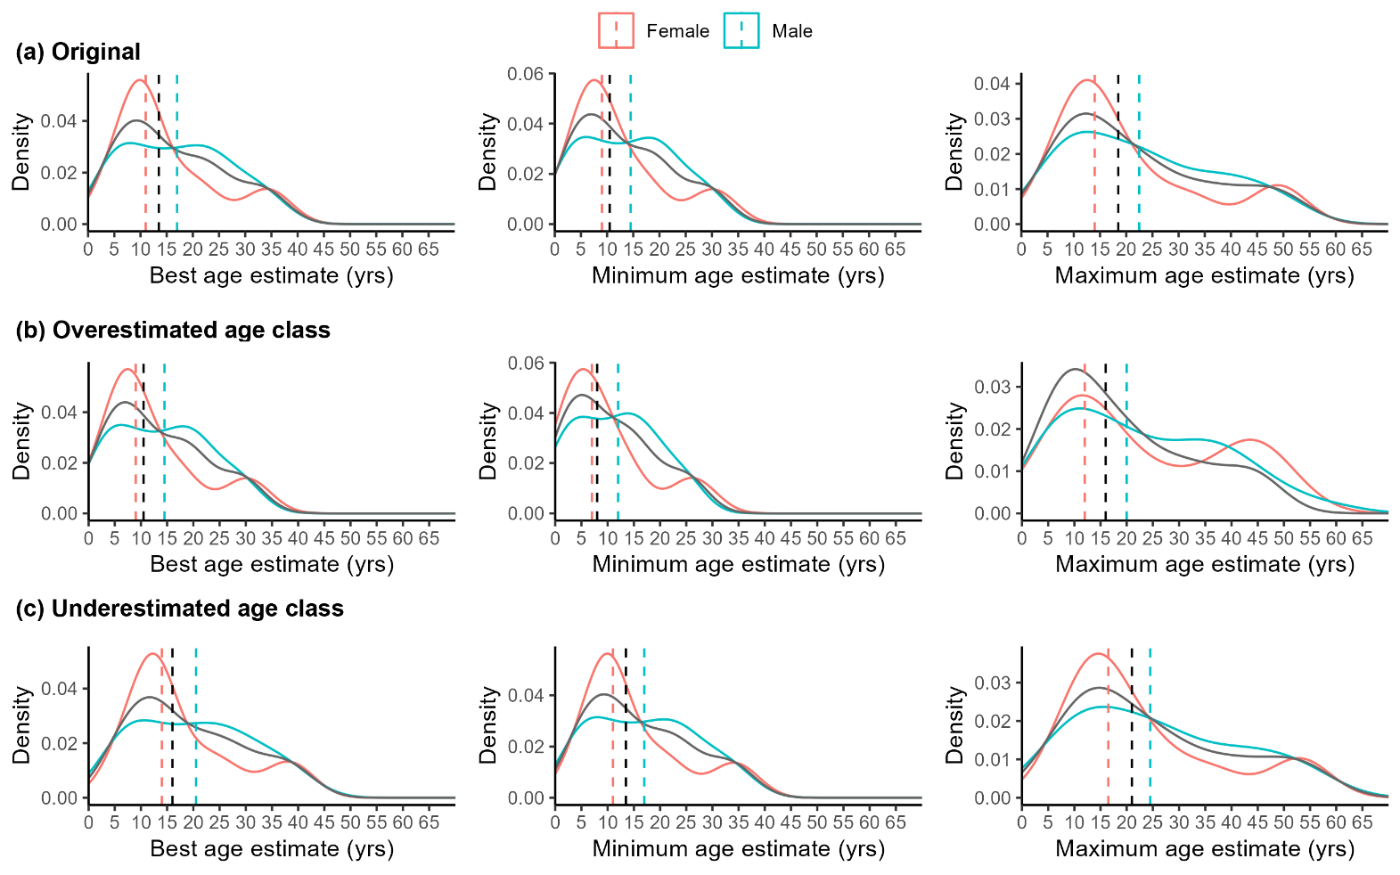
Figure S4. Density distributions of catalog-derived age estimates for all biopsy sampled Hawaiian false killer whales with a confidence rating of four or higher (grey lines) and by sex (colored lines). (a) original age estimates; (b) estimates in the case we overestimated age class when first seen; (c) estimates in the case we underestimated age class when first seen (see Table S2 for details on age adjustments corresponding to (b) and (c)). Vertical black dashed lines represent median values for each category (all, female, male); plots where the black dashed line is not visible indicates that it is equal to the median value of males or females (see Table S4).
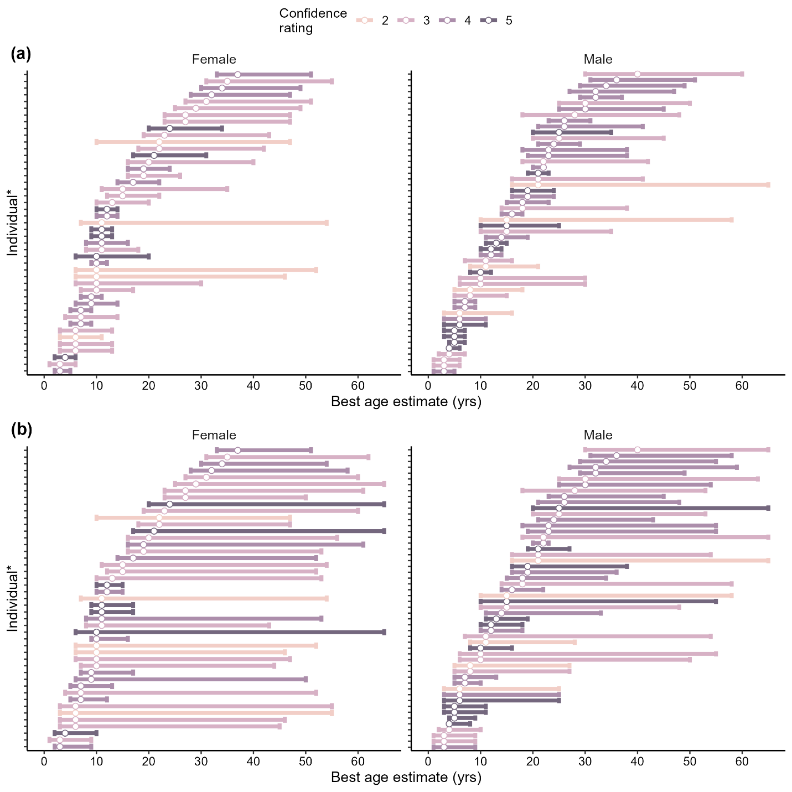
Figure S5. Age estimates (circle = best age, bars = minimum-maximum age) for females and males colored by confidence rating derived from (a) the original protocol and (b) the amended protocol where maximum age was calculated based on the maximum age of one age class above that when first seen.

