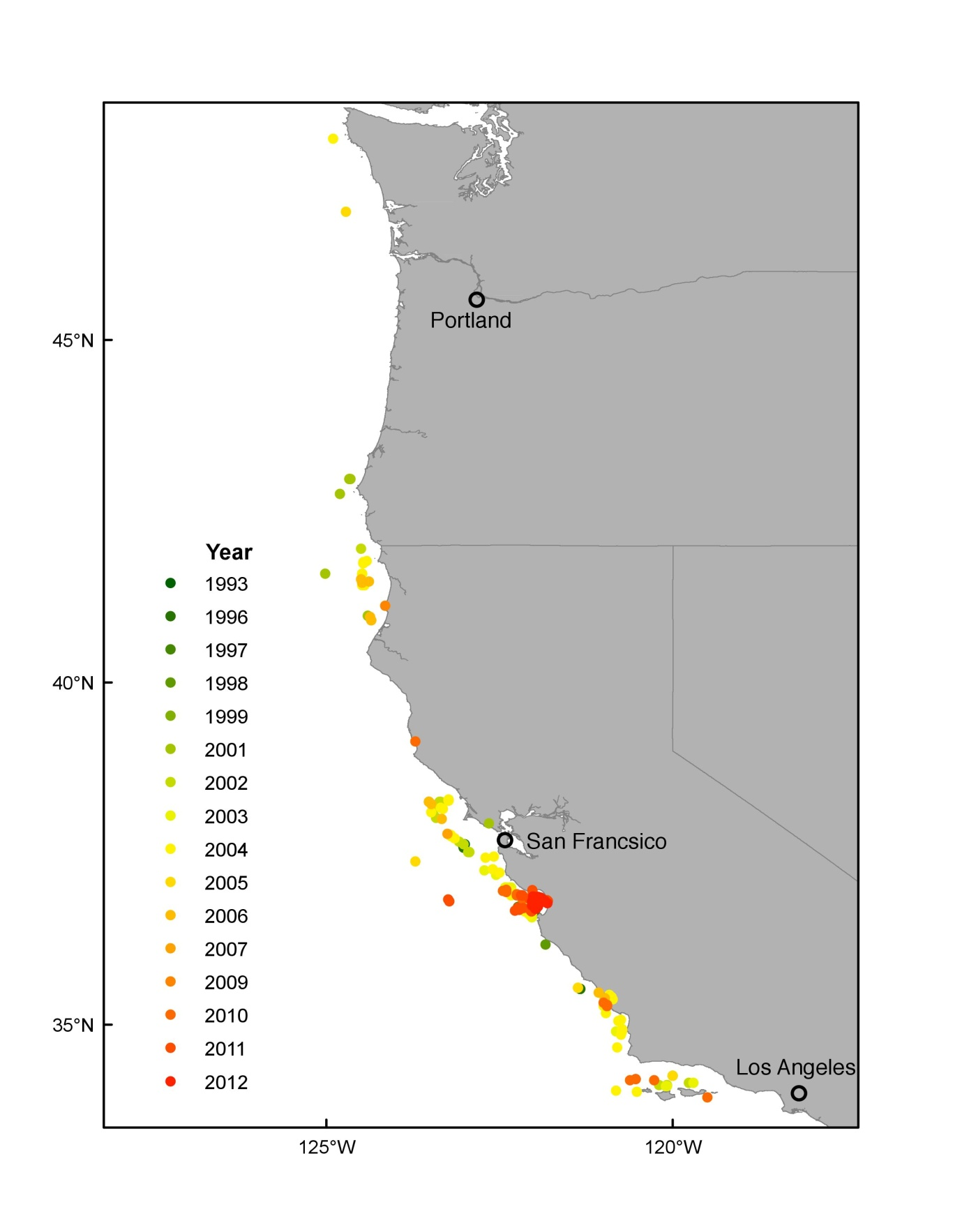

Figure S1: Map of study area with humpback whale sample locations shown color-coded by year of collection.



Figure S2: δ15N and δ13C values measured in 295 skin samples from humpback whales collected in the California Current from 1993-2012. Mean values are represented with a bold bar. Box and whisker symbols indicate 5th and 95th percentiles. Potential outliers are indicated as circles.

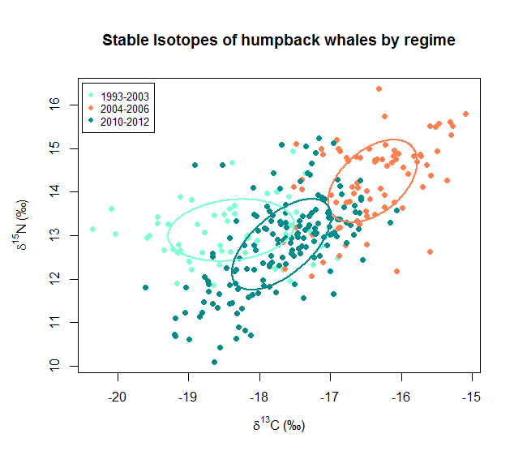

Figure S3: δ15N and δ13C values measured in 295 skin samples from humpback whales collected in the California Current from 1993-2012. Bayesian ellipse area (solid lines) represent the isotopic niche for three distinct time periods.

Table S1: Centroid locations and dispersion metrics for isotope samples collected during three different time periods of the study in the California Current Ecosystem. Dispersion metrics are mean distance to centroid (MDC) and mean distance to nearest neighbor (MNN).

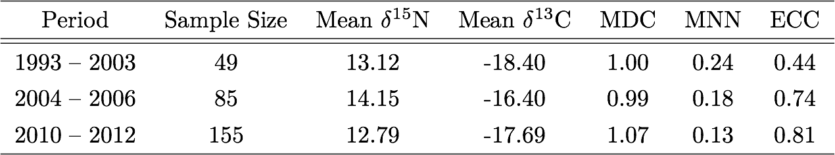

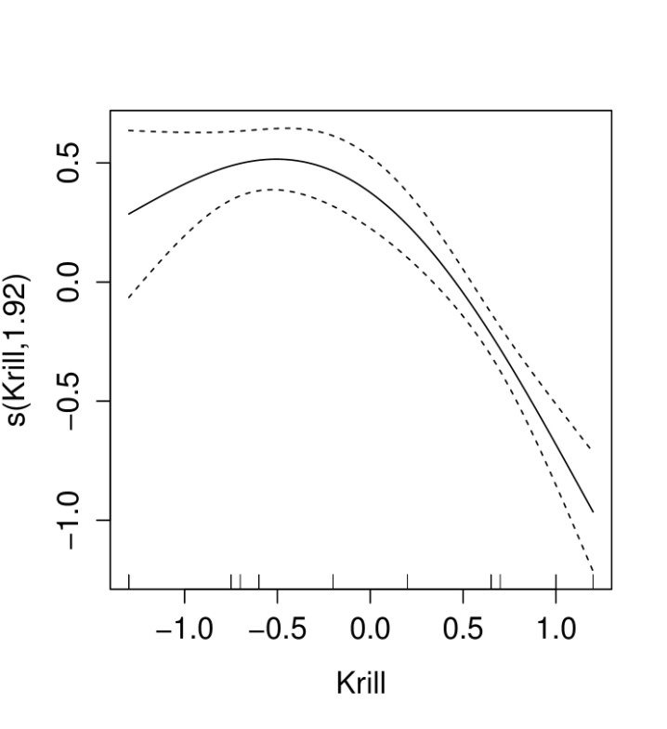

Figure S4: Generalized additive model function of humpback whale δ15N in relation to krill abundance anomalies only. Dashed lines are two standard error bars.

Table S2: Summary of generalized additive models relating humpback whale δ15N and δ13C to prey abundance anomalies and oceanographic variables.

|  |  |  |  |
| --- | --- | --- | --- |
| Model | AIC | Explained Deviance | R-squared |
| δ15N Models | | | |
| SST + Krill | 752.47 | 38.4% | 0.377 |
| SST + Krill + Anchovy | 753.60 | 38.5% | 0.376 |
| SST + Upwelling | 753.75 | 38.7% | 0.377 |
| δ13C Models | | | |
| Upwelling + Anchovy + PDO | 555.30 | 60.4% | 0.597 |
| Upwelling + Anchovy + PDO + NPGO | 557.27 | 60.4% | 0.596 |
| Upwelling + Anchovy | 558.50 | 59.9% | 0.592 |