Supplementary Material

Supplementary Data
Supplementary Material should be uploaded separately on submission. Please include any supplementary data, figures and/or tables. All supplementary files are deposited to FigShare for permanent storage and receive a DOI.
Supplementary material is not typeset so please ensure that all information is clearly presented, the appropriate caption is included in the file and not in the manuscript, and that the style conforms to the rest of the article. To avoid discrepancies between the published article and the supplementary material, please do not add the title, author list, affiliations or correspondence in the supplementary files.

Supplementary Figures and Tables
Supplementary Table 1. Deployment metadata. “Deployment date”, mm/dd/yyyy tag was deployed. “Tag #”, individual tag identifiers, alphanumeric tag numbers indicate instances where the same tag was deployed more than once in the same day. “Whale ID”, individual whale catalog identification number (maintained & assigned by CRC). “Location”, general deployment location. S.R. (Hz), tag accelerometer sampling rate in hertz. “Accel. (hh:mm)”, cumulative total of available accelerometer data for the deployment. “Audio Source”, source of full-frequency audio data. “Aud. (hh:mm)”, cumulative total of available acoustic data for the deployment. *** Indicates whales not currently assigned identification numbers. Repeat deployments on same individuals is noted here as italicized rows.

Deployment Date | Tag # | Whale ID | Location | S.R. (Hz) | Accel. (hh:mm) | Audio Source | Aud.  (hh:mm)
03/25/2016 | 22 | CRC-723 | Everett, WA. | 200 | 23:03 | Camera | 07:59
03/25/2016 | 25a | CRC-49 | Everett, WA. | 200 | 00:58 | Camera | 00:55
03/25/2016 | 25b | CRC-383 | Everett, WA. | 200 | 13:00 | Camera | 01:40
04/06/2016 | 21 | CRC-723 | Everett, WA. | 400 | 37:38 | Camera | 06:15
04/06/2016 | 22 | CRC-21 | Everett, WA. | 400 | 18:10 | Camera | 05:24
04/07/2016 | 25 | CRC-383 | Everett, WA. | 400 | 04:26 | Camera | 04:11
09/01/2019 | 47 | CRC-1863 | WA Coast | 400 | 01:35 | None | 00:00
09/02/2019 | 46 | CRC-2354 | WA Coast | 400 | 00:08 | Camera | 00:08
09/02/2019 | 47 | CRC-2243 | WA Coast | 400 | 00:08 | Camera | 00:08
04/15/2021 | 58 | CRC-531 | Everett, WA. | 400 | 27:57 | HTI 96 | 15:39
04/15/2021 | 71 | *** | Everett, WA. | 400 | 01:20 | HTI 96 | 01:20
04/16/2021 | 70 | *** | Everett, WA. | 400 | 00:05 | HTI 96 | 00:05

Supplementary Table 2. By-deployment data summarization and variation. “Deployment ID”, the alphanumeric deployment identifier, starting with the two letter abbreviated species name (Er), followed by the tag number, and the date the tag was deployed in YYMMDD format. “n day accel. data”, number of days of accelerometry data collected. “n day acous. data”, number of days of acoustic (hydrophone or camera) data collected. “n env. calls”, total number of identified calls not considered to originate from the tagged animal. “n tagged calls”, total number of identified calls considered to originate from the tagged animal. “n tagged calls w/ acous.”, total number of calls considered to originate from the tagged animal also supported by acoustic recording. “n tagged calls accel. only”, total number of signals considered to originate from the tagged animal and not supported by acoustic recording. “n calls acous. supported”, total number of calls both from tagged animals and not, that were recorded via tag acoustics. “n calls”, total number of all types of calls and signals (tagged and nontagged, acoustic and accelerometer recorded). Cumulative totals, means, and standard deviations are included at the bottom of the table as italicized rows with the deployment ID of “All Deployments”, “Mean”, and“std (+/-)”, respectively. A value of “NA” indicates where tag acoustics weren’t enabled for the respective deployment.

Deployment ID | n day accel. data | n day acous. data | n env. calls | n tagged calls | n tagged calls w/ acous. | n tagged calls accel. only | n calls acous. supported | n calls
Er22-160325 | 0.96 | 0.33 | 3 | 0 | 0 | 0 | 3 | 3
Er25a-160325 | 0.04 | 0.04 | 4 | 0 | 0 | 0 | 4 | 4
Er25b-160325 | 0.01 | 0.07 | 5 | 8 | 3 | 5 | 8 | 13
Er21-160406 | 1.58 | 0.26 | 0 | 6 | 0 | 6 | 0 | 6
Er22-160406 | 0.76 | 0.23 | 9 | 11 | 11 | 0 | 20 | 20
Er25-160407 | 0.18 | 0.17 | NA | 15 | NA | 15 | 0 | 15
Er47-190901 | 0.07 | 0.00 | NA | 0 | NA | 0 | 0 | 0
Er46-190902 | 0.01 | 0.01 | 0 | 0 | 0 | 0 | 0 | 0
Er47-190902 | 0.01 | 0.01 | 0 | 0 | 0 | 0 | 0 | 0
Er58-210415 | 1.16 | 0.65 | 41 | 15 | 9 | 6 | 50 | 56
Er71-210415 | 0.06 | 0.06 | 21 | 1 | 1 | 0 | 22 | 22
Er70-210415 | 0.00 | 0.00 | 0 | 0 | 0 | 0 | 0 | 0
All Deployments | 4.83 | 1.82 | 83 | 56 | 24 | 32 | 107 | 139
Mean | 0.40 | 0.15 | 8.30 | 4.67 | 2.40 | 2.67 | 8.92 | 11.58
std (+/-) | 0.56 | 0.19 | 13.18 | 6.11 | 4.14 | 4.64 | 15.13 | 16.14

Supplementary Table 3. Descriptive statistics of call by class. ‘Type’; class of call based on currently accepted gray whale call classification schemes (Dahlheim, 1987). ‘n’; number of calls belonging to that class. ‘Avg. Duration (s)’; mean duration & (+/-) standard deviation (st.d) of call in seconds; ‘Avg. IPI (s)’; mean inter-pulse-interval or duration between calls in seconds, *** only applicable to class 1 type calls occurring in sequences of more than one; ‘Avg. Low Freq. (Hz)’; mean & (+/-) st.d lowest frequency call component in hertz; ‘Avg. High Freq. (Hz)’; mean & (+/-) st.d highest frequency call component in hertz; ‘Avg. Freq. Range (Hz)’; mean & (+/-) st.d of the total difference between high and low frequency call components in hertz.

Type | n | Avg. Duration (s) |  | Avg. IPI (s) *** |  | Avg. Low Freq (Hz) |  | Avg. High Freq. (Hz) |  | Avg. Freq. Range (Hz)
Class 1 | 11 | 0.011 | (+/-) 0.004 | 0.199 | (+/-) 0.02 | 425.82 | (+/-) 331.26 | 1331.72 | (+/-) 796.87 | 905.9 | (+/-) 483.66
Class 2 | 54 | 0.629 | (+/-) 0.358 | N/A | N/A | 43.87 | (+/-) 22.92 | 229.22 | (+/-) 123.25 | 185.35 | (+/-) 107.00
Class 3 | 31 | 1.06 | (+/-) 0.54 | N/A | N/A | 49.89 | (+/-) 46.80 | 264.44 | (+/-) 197.32 | 214.55 | (+/-) 198.29
Class 4 | 37 | 0.561 | (+/-) 0.430 | N/A | N/A | 71.90 | (+/-) 79.43 | 611.55 | (+/-) 360.07 | 539.65 | (+/-) 332.79

Supplementary Table 4. Comparison of previously reported gray whale calling rates (calls/whale/unit of time). “Source/Authors”, literature cited in following columns; “General Location”, general location of reported call rate; “Rate Reported”, the calling rate as originally reported by the authors; “Rate Method”, the method by which the authors calculated the ‘rate reported’ with ‘hourly’ indicating the calling rate was calculated as calls/whale/hour and ‘daily’ indicating rates calculated as calls/whale/day; “Hourly rate”, takes the original rate reported and converts to an hourly scale (daily rate/24) if necessary. Note that only studies with call rate estimation methods comparable to the ones used in this study were included in this table. For instance, Rannankari, Burnham, and Duffus (2018) evaluated calling rates as overall calls per unit of time, with no distinction as to the number of animals producing said rate, and therefore was not considered comparable to the rates reported here.

Source/Authors | General Location | Rate Reported | Rate Method | Hourly Rate
Dahlheim, 1987 | Baja California lagoons, MX | 0.33 | hourly | 0.33
Dahlheim, 1987 | Baja California lagoons, MX | 0.25 | hourly | 0.25
Dahlheim, 1987 | St. Lawrence Island, Bering Sea, AK, USA | 0.01 | hourly | 0.01
Crane & Lashkari, 1996 | Monterey Bay & Carmel Bay, CA, USA - shallow water | 0.05 | hourly | 0.05
Crane & Lashkari, 1996 | Monterey Bay & Carmel Bay, CA, USA -deep water | 0.01 | hourly | 0.01
Guazzo et al., 2017 | Central California, USA | 5.70 | daily | 0.24
Guazzo et al., 2019 | Central California, USA-north & southward migration | 7.50 | daily | 0.31
Clayton et al., 2023 | Puget Sound, Washington | 0.67 | hourly | 0.67

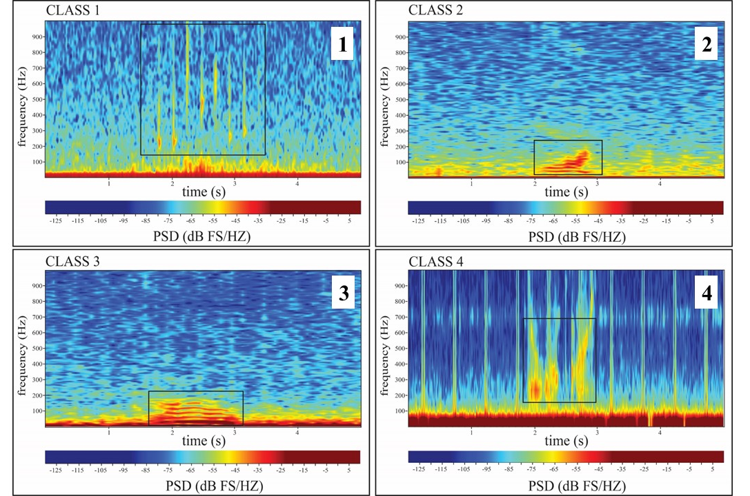
Supplementary Figures
Supplementary Figure 1. Spectral representation of each previously categorized call type observed in this study. All spectrograms were generated with Raven Pro Interactive Sound Software and are given on the same time scale (5 seconds) for ease of comparison. Note that the color bar scale, represented as Power Spectral Density (PSD (decibels relative to full scale/hertz)) may vary by call example. (1) a series of Class 1 or S1 pulsive knocks, with 1024-point Hanning window size. (2) a Class 2 frequency modulated tonal call, with 4096-point Hanning window size. (3) a Class 3 non-frequency modulated tonal call, with 4096-point Hanning window size. (4) higher frequency Class 4 ‘rumble’ calls, with a 512-point Hanning window size.

Supplementary Figure 1.

