Supplementary Material

Supplementary Figures

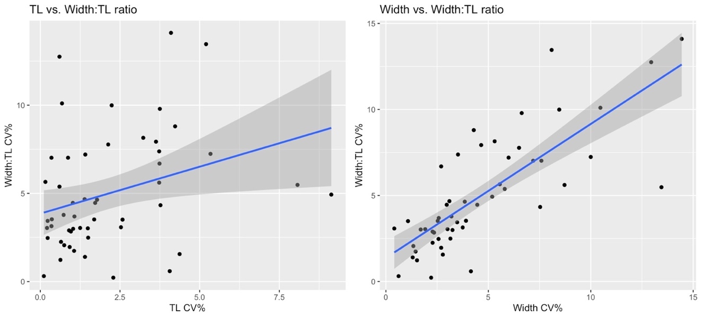
Supplementary Figure S1: Variation in Width:TL ratios for individuals with multiple images. For individuals with measurements from multiple images (up to 5 images, and after images were filtered for quality scores of 1 or 2, see Data Filtering section in the Methods), the coefficient of variation (CV%) was calculated for the total length (TL), Width (measured as the single-width measurement, “SW”, described in the One-Dimensional: Single-Width (SW_{std}) section in the Methods), and the ratio between the two (Width:TL). Variation in Width:TL ratios was influenced more by variation in the Width measurements (R² = 0.60) rather than variation in TL measurements (R² = 0.08). This indicates that filtering for image quality 1 and 2 is robust to potential biases in width measurements that may be caused by variation in TL, i.e., arising from any slight bending or arching of the animal.

