**Supplementary Material**



Fig. S1. *Steno bredanensis*. K number of populations (x-axis) from STRUCTURE runs showing 😐 values (y-axis) of the most likely number of populations for rough-toothed dolphins in the Central Pacific.



Fig. S2. *Steno bredanensis*. K number of populations (x-axis) from STRUCTURE runs showing 😐 values (y-axis) of the most likely number of populations for rough-toothed dolphins in the Hawaiian Islands.

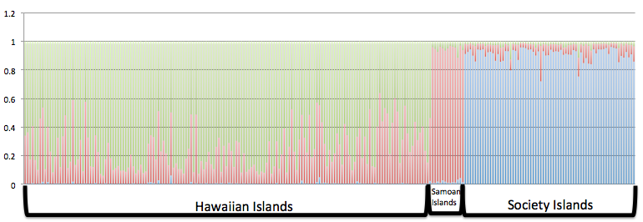

a) K=3

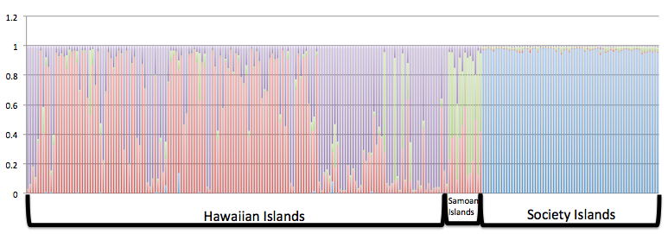

b) K=4

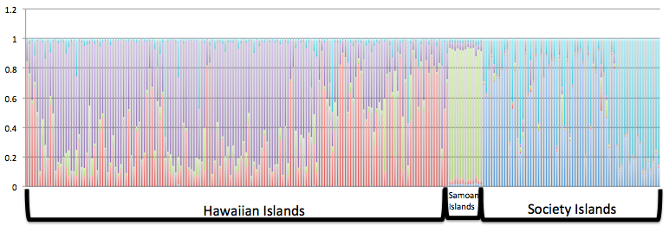

c) K=5

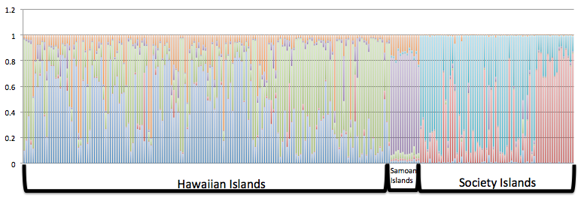

d) K=6

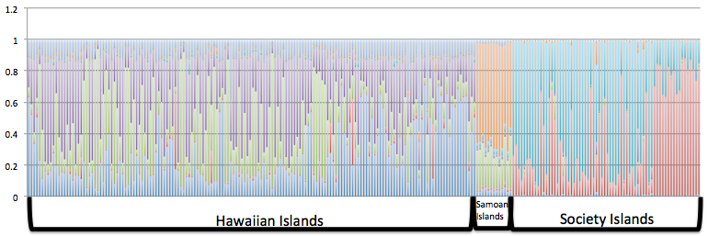

e) K=7

Fig. S3: *Steno bredanensis*. Graphical representation of the results of the STRUCTURE analysis for all archipelagos using a prior for sampling locations with (a) K=3 populations, (b) K=4 populations, (c) K=5 populations, (d) K=6 populations and (e) K=7 populations.

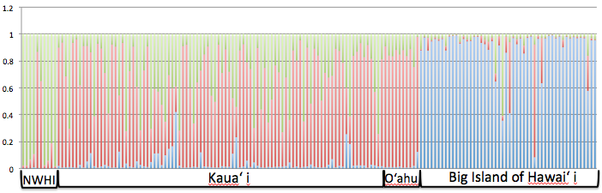

a) K=3

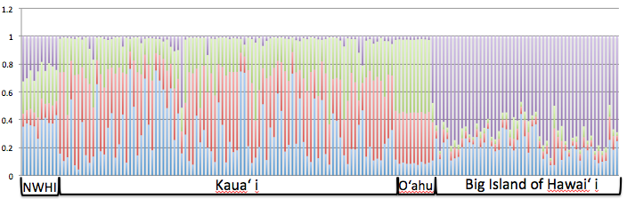

b) K=4

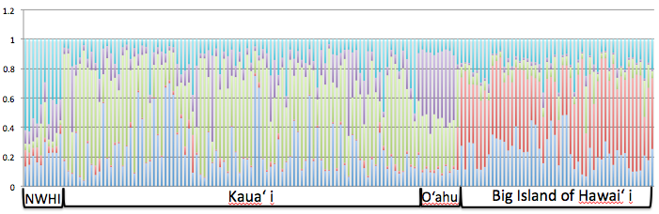

c) K=5

Fig. S4: *Steno bredanensis*. Graphical representation of the results of the STRUCTURE analysis for the Hawaiian Islands only using a prior for sampling locations (LocPrior) with (a) K=3 populations, (b) K=4 populations, (c) K=5 populations.

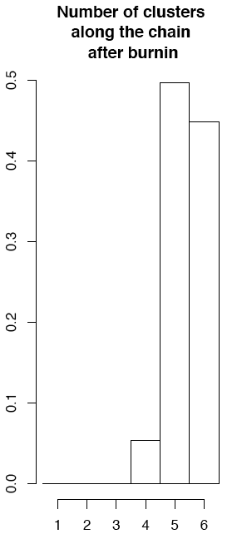

Fig. S5: *Steno bredanensis*. Graphical representation of the number of clusters identified by *GENELAND* for the Hawaiian Islands. The program identified between 4 and 6 clusters or populations, however, the membership showed only 5 populations and 1 “ghost” population (see text for details).

 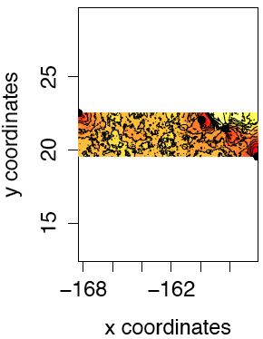

a) b)

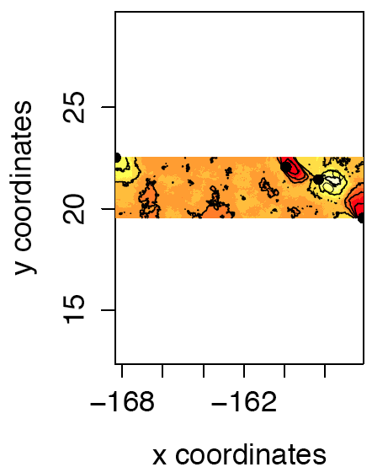 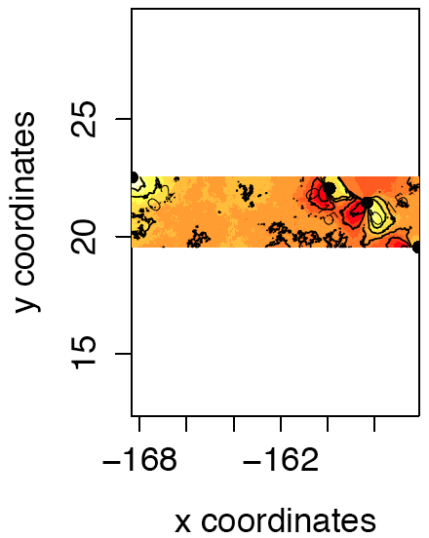

c) d)

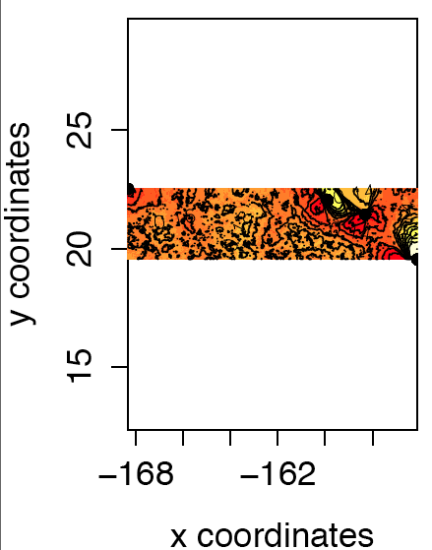

e)

Fig. S6: *Steno bredanensis*. Maps of *GENELAND* individual assignments of rough-toothed dolphins in the Hawaiian Islands of clusters for K=5 where “y coordinates” are shown as latitude and “x coordinates” are shown as longitude. The black dots represent the four sampling areas, top left is NWHI, followed by Kaua‘i, O‘ahu, and Hawai‘i in the lower right corner. The four plots represent the assignment of pixels to each cluster: (a) Hawai‘i (b) the Windward side of Kaua‘i, (c) NWHI and O‘ahu, (d) NWHI, O‘ahu and Kaua‘i, (e) the northernmost Leeward side of Kaua‘i. The assignment of pixels to the sixth cluster is not shown, as no individuals are assigned to it (“ghost cluster”, see text for further details). The highest membership values are in light yellow and the level curves illustrate the spatial changes in assignment values. Contour lines indicate the spatial position of genetic discontinuities and lighter colors indicate higher probabilities of population membership.

Table S1: *Steno bredanensis*. Summary of microsatellite loci over 278 individuals genotyped in this study. *N* gives the number of individuals successfully typed at each locus. K is the number of alleles per locus. **ToA** is the annealing temperature used for each locus. Ho is the observed heterozygosity and He is the expected heterozygosity calculated for each locus.

|  |  |  |  |  |  |  |  |  |
| --- | --- | --- | --- | --- | --- | --- | --- | --- |
| Locus | N | K | Mg+2  (mM) | ToA | Ho | He | Label | Reference |
| DlrFCB1 | 302 | 11 | 2.5 | 45 | 0.925 | 0.743 | VIC | (Buchanan et al. 1996) |
| GT39 | 308 | 13 | 2.5 | 62 | 0.766 | 0.790 | VIC | (Caldwell et al. 2002) |
| Ppho110 | 289 | 3 | 1.5 | 60 | 0.365 | 0.359 | FAM | (Rosel et al. 1999) |
| 415/416 | 301 | 9 | 2.5 | 45 | 0.700 | 0.726 | NED | (Amos et al. 1993) |
| MK5 | 291 | 14 | 1.5 | 55 | 0.907 | 0.807 | VIC | (Krützen et al. 2001) |
| MK6 | 297 | 9 | 1.5 | 50 | 0.558 | 0.534 | NED | (Krützen et al. 2001) |
| MK8 | 282 | 10 | 1.5 | 50 | 0.755 | 0.838 | NED | (Krützen et al. 2001) |
| MK9 | 278 | 8 | 1.5 | 50 | 0.818 | 0.815 | VIC | (Krützen et al. 2001) |
| Sgui 17 | 299 | 6 | 2.5 | 57 | 0.487 | 0.511 | NED | (Cunha & Watts 2007) |
| KWM12 | 302 | 10 | 1.5 | 45 | 0.741 | 0.699 | VIC | (Hoelzel et al. 1998) |
| TexVet5 | 261 | 5 | 1.5 | 50 | 0.633 | 0.683 | FAM | (Rooney et al. 1999) |
| SloSl-9 | 269 | 7 | 2.5 | 55; 53.5 | 0.465 | 0.494 | NED | (Galver 2002) |
| SloSl-10 | 261 | 9 | 2.5 | 55; 53.5 | 0.497 | 0.511 | FAM | (Galver 2002) |
| SloSl-4 | 270 | 12 | 2.5 | 50.5; 50 | 0.677 | 0.701 | NED | (Galver 2002) |

Table S2: *Steno bredanensis*. Pairwise ΦST differentiation below diagonal and G”ST above the diagonal among populations in the Hawaiian, Society and Samoan Islands mtDNA control region Statistically significant ΦST values are bolded and italicized, with * significant at p < 0.05; ** significant at p < 0.001.

|  |  |  |  |  |  |  |  |  |
| --- | --- | --- | --- | --- | --- | --- | --- | --- |
|  | n  mtDNA | Kaua`i | NWHI | O‘ahu | Hawai‘i | Mo‘orea/  Tahiti | Ra‘iatea/  Huahine | Samoan  Islands |
|  |  |  |  |  |  |  |  |  |
| Kaua‘i | 97 |  | 0.079 | 0.065 | ***0.064*** | ***0.143*** | ***0.220*** | ***0.161*** |
| NWHI | 18 | 0.004 |  | 0.076 | ***0.047*** | ***0.126*** | ***0.294*** | ***0.213*** |
| O‘ahu | 9 | 0.021 | 0.008 |  | ***0.100*** | ***0.115*** | ***0.312*** | ***0.146*** |
| Hawai‘i | 56 | 0.235** | 0.092* | 0.216** |  | ***0.149*** | ***0.281*** | ***0.148*** |
| Mo‘orea/  Tahiti | 54 | 0.239** | 0.387** | 0.423** | 0.378** |  | ***0.248*** | ***0.234*** |
| Ra‘iatea/  Huahine | 20 | 0.342** | 0.219** | 0.598** | 0.571** | 0.591** |  | ***0.207*** |
| Samoan Islands | 16 | 0.356** | 0.237** | 0.513** | 0.377** | 0.394** | 0.222** |  |

Table S3: *Steno bredanensis*. *P*-values generated for population comparisons of haplotype diversity derived from mtDNA control region haplotype frequencies for rough-toothed dolphins in the Hawaiian, Society and Samoan Islands. Significant values are bolded and italicized.

|  |  |  |  |  |  |  |  |
| --- | --- | --- | --- | --- | --- | --- | --- |
|  | Kaua‘i | NWHI | O‘ahu | Hawai‘i | Mo‘orea/  Tahiti | Ra‘iatea/  Huahine | Samoan  Islands |
|  |  |  |  |  |  |  |  |
| Kaua‘i |  |  |  |  |  |  |  |
| NWHI | ***0.013*** |  |  |  |  |  |  |
| O`ahu | ***0.046*** | 0.06 |  |  |  |  |  |
| Hawai‘i | ***0.006*** | ***0.019*** | ***0.041*** |  |  |  |  |
| Mo‘orea/  Tahiti | ***0.008*** | ***0.006*** | ***0.045*** | ***0.013*** |  |  |  |
| Ra‘iatea/  Huahine | ***0.008*** | ***0.006*** | ***0.047*** | ***0.013*** | 0.06 |  |  |
| Samoan Islands | ***<0.001*** | ***0.013*** | ***0.047*** | ***0.007*** | ***0.007*** | ***0.007*** |  |

Table S4: *Steno bredanensis*. P values generated for archipelago comparisons of haplotype diversity derived from mtDNA control region haplotype frequencies for rough-toothed dolphins in the Hawaiian, Society and Samoan Islands. Significant values are bolded and italicized.

|  |  |  |  |  |
| --- | --- | --- | --- | --- |
|  | Hawaiian Islands | Society Islands | Samoan Islands |  |
| Hawaiian Islands |  |  |  |  |
| Society Islands | ***0.019*** |  |  |  |
| Samoan Islands | ***0.001*** | ***0.009*** |  |  |

Table S5: *Steno bredanensis*. Mean log-likelihood and *K* for Structure runs for rough-toothed dolphin samples in the Central Pacific using K for 1 to 7 populations, 5 iterations for each population.

|  |  |  |  |
| --- | --- | --- | --- |
| *K* | Mean | SD | *K* |
| 1 | -11174.8600 | 0.1140 | --- |
| 2 | -10855.3600 | 2.1732 | 99.924241 |
| 3 | -10753.0200 | 19.7992 | 3.254682 |
| 4 | -10715.1200 | 62.6263 | 0.165745 |
| 5 | -10666.8400 | 9.8556 | 8.975601 |
| 6 | -10707.0200 | 245.7508 | 0.383722 |
| 7 | -10841.5000 | 0.000000 | --- |

Table S6: *Steno bredanensis*. Mean log-likelihood and *K* for Structure runs for rough-toothed dolphin samples in the Hawaiian Islands using K for 1 to 5 populations, 5 iterations for each population.

|  |  |  |  |
| --- | --- | --- | --- |
| *K* | Mean | SD | *K* |
| 1 | -7060.18000 | 0.521536 | --- |
| 2 | -7010.80000 | 26.915980 | 8.911435 |
| 3 | -7201.28000 | 74.150907 | 0.988255 |
| 4 | -7318.48000 | 179.45182 | 0.486259 |
| 5 | -7348.42000 | 223.80549 | --- |

Table S7: *Steno bredanensis.* Two-tailed tests of sex-biased dispersal based on the comparison of sex-specific microsatellite (msat) FST, mtDNA FST, inbreeding coefficient (FIS), mean corrected assignment index (mAIc), and variance of corrected assignment index (vAIc). The mtDNA sample size (n) is indicated in parentheses if it differed from the microsatellite sample size.

|  |  |  |  |
| --- | --- | --- | --- |
|  | Female | Male | P |
| North Pacific  (4 populations) |  |  |  |
| n | 100 (110) | 59 (70) |  |
| FST mstat | 0.024 | 0.016 | 0.418 |
| FST mtDNA | 0.137 | 0.109 | 0.212 |
| FIS | 0.050 | 0.089 | 0.238 |
| mAIc | -0.088 | 0.057 | 0.320 |
| vAIc | 14.55 | 22.94 | 0.110 |
|  |  |  |  |
| South Pacific  (3 populations) |  |  |  |
| n | 50 (55) | 30 (31) |  |
| FST mstat | 0.073 | 0.070 | 0.434 |
| FST mtDNA | 0.149 | 0.123 | 0.255 |
| FIS | 0.002 | 0.001 | 0.751 |
| mAIc | 0.487 | -0.297 | 0.100 |
| vAIc | 17.03 | 10.32 | 0.192 |
|  |  |  |  |
| Overall  (7 populations) |  |  |  |
| n | 150 (165) | 89 (101) |  |
| FST mstat | 0.050 | 0.044 | 0.615 |
| FST mtDNA | 0.144 | 0.116 | 0.512 |
| FIS | 0.042 | 0.061 | 0.441 |
| mAIc | 0.103 | -0.064 | 0.773 |
| vAIc | 15.42 | 18.53 | 0.412 |

Table S8: *Steno bredanensis*: The p-values resulting from the HWE test for deviation of Hardy-Weinberg Equilibrium.

|  |  |  |  |  |  |  |  |
| --- | --- | --- | --- | --- | --- | --- | --- |
| Locus | NWHI | Kauai | Oahu | Hawaii | Moorea | Raiatea | Samoan  Islands |
| SloSl-9 | 0.856 | 0.011 | 0.993 | 0.602 | 0.999 | 0.901 | 0.999 |
| SloSl-4 | 0.821 | 0.010 | 0.997 | 0.001 | 0.358 | 0.136 | 0.031 |
| SloSl-10 | 0.572 | 0.0946 | 0.339 | 0.024 | 0.017 | 0.125 | 0.020 |
| 415/416 | 0.427 | 0.331 | 0.137 | 0.026 | 0.354 | 0.980 | 0.206 |
| DlrFCB1a | 0.429 | 0.001 | 0.528 | 0.061 | 0.999 | 0.2132 | 0.782 |
| GT39 | 0.999 | 0.001 | 0.069 | 0.003 | 0.033 | 0.888 | 0.974 |
| KW12 | 0.289 | 0.287 | 0.310 | 0.420 | 0.166 | 0.153 | 0.198 |
| MK5 | 0.600 | 0.588 | 0.992 | 0.156 | 0.940 | 0.730 | 0.788 |
| MK6 | 0.999 | 0.636 | 0.994 | 0.997 | 0.260 | 0.985 | 0.998 |
| Sgui17 | 0.899 | 0.775 | 0.909 | 0.062 | 0.221 | 0.435 | 0.993 |
| Ppho110 | 0.1765 | 0.293 | 0.995 | 0.263 | 0.491 | 0.853 | 0.999 |
| TexVet5 | 0.648 | 0.167 | 0.134 | 0.057 | 0.061 | 0.398 | 0.182 |
| MK8 | 0.022 | 0.120 | 0.999 | 0.020 | 0.169 | 0.052 | 0.998 |
| MK9 | 0.030 | 0.012 | 0.899 | 0.009 | 0.887 | 0.561 | 0.996 |